**Let’s Make a Student’s Life Easier**

Data Science Capstone - IBM Data Science Professional Certificate on Coursera

*SAPNA TARE*

**Introduction**

Student move to Metropolitan cities for higher educations. Moving to metro cities is extremely exciting for students, but it can also be a little overwhelming. Since these cities very crowded. Students face the problem of commute to reach their destinations. Students having part time job/night time classes struggle to reach destination from universities/colleges on time.

**Business Problem: -**

For the problem, Let’s say XYZ company decided to construct off-campus /student -housing community (campus for students) /dorms to nearby universities/colleges in different states across the USA.

Unless students who live on campus work away from the school, there is little need for transportation and commute is biggest problem. Off Campus housing should be close to universities/collages. It should be within walking distance to classrooms, libraries, university center. It should be closer to other places such as book store, a variety of food locations, and campus recreational facilities. It will save quality time of student to avoid commute

This report can help to companies those are planning to start building an off campus / Dorms for student in a metropolitan city.

XYZ company has to figure out all the neighborhood locations where top universities are exists and start their business around.

The problem we aim to analyze the Universities locations across the USA and find the best place for our students to stay and make their life easier.

**Data**

**For this project we need the following Data**

**Foursquare**

<https://api.foursquare.com/v2/venues/explore>

**Top 5 states in USA for Higher educations**: -

1. New York
2. Boston, MA
3. Chicago, IL
4. Jersey City, NJ
5. San Francisco, CA

**Methodologies: -**

**Expletory Analysis**

As a data scientist what would be my approach to solve this business Problem.

Main target here is to asses which City would have the highest universities locations density. I used the Four-Square API through the venues channel. I used the near query to get venues in the cities. Also, I use the CategoryID to set it to show only targeted places.

Example: -

**Find Category ID**

<https://developer.foursquare.com/docs/resources/categories>

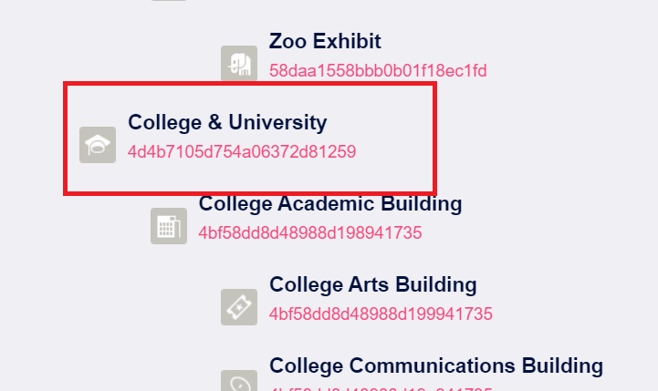

**Find Venue using Category ID**

https://api.foursquare.com/v2/venues/explore?&client_id=&client_secret=&v=20180605&New York, NY&limit=100&categoryId= **4d4b7105d754a06372d81259**

Using Category Id for collage /universities from Foursquare API we fetch the venues which limits us to maximum of 100 venues per query.

Moreover, I repeated this request for the 5 major targeted cities and got their top 100 venues. I saved the name and coordinate data only from the result and plotted them on the map for visual inspection.

Next, to get an indicator of the density of colleges/universities Places where XYZ companies targeted to start construction for off campus for students, I calculated a center coordinate of the venues to get the mean longitude and latitude values. Then I calculated the mean of the Euclidean distance from each venue to the mean coordinates. That was my indicator; mean distance to the mean coordinate

1. Foursquare API
2. IBM Watson cloud -python

Libraries needed

* + Numpy and pandas: - Data handing
  + geoPy: - to get coordinates latitude and longitude information
  + folium: - to visualize result on map

## **Results: -**

1. **Total number of Universities in targeted locations.** 1

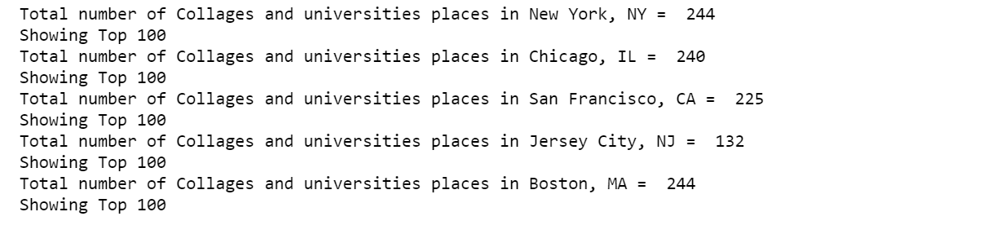

1. **Mean distance from Mean coordinates**

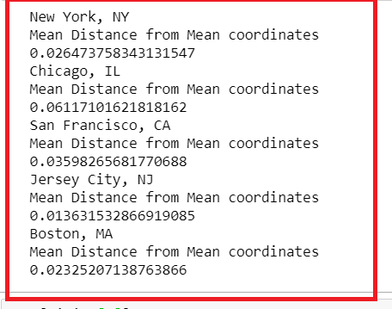

**Visualize Result**

#### New York:

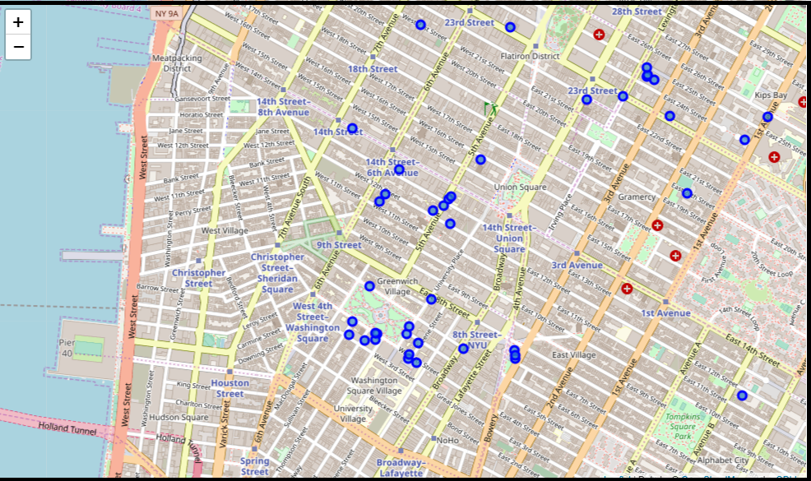

**Chicago, IL**

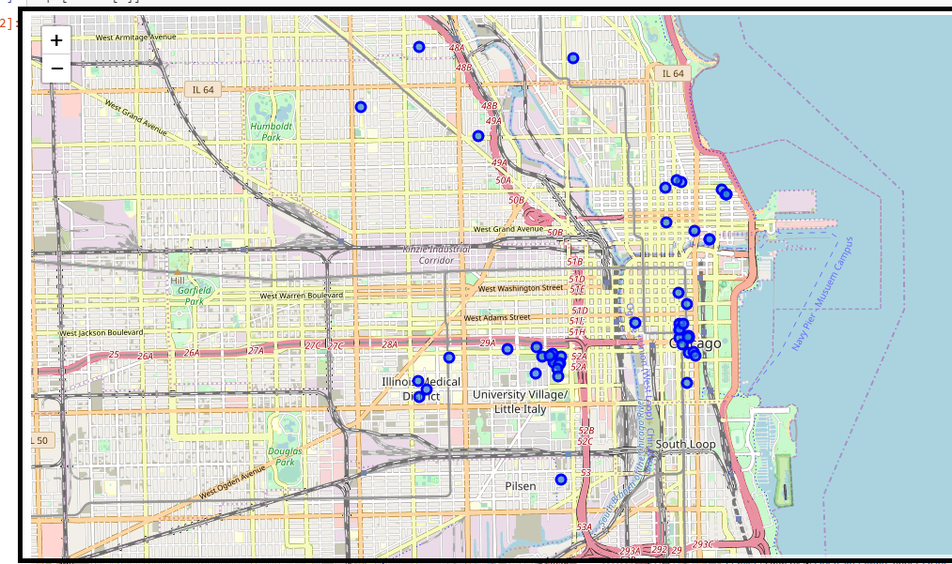

**San Francisco, CA**

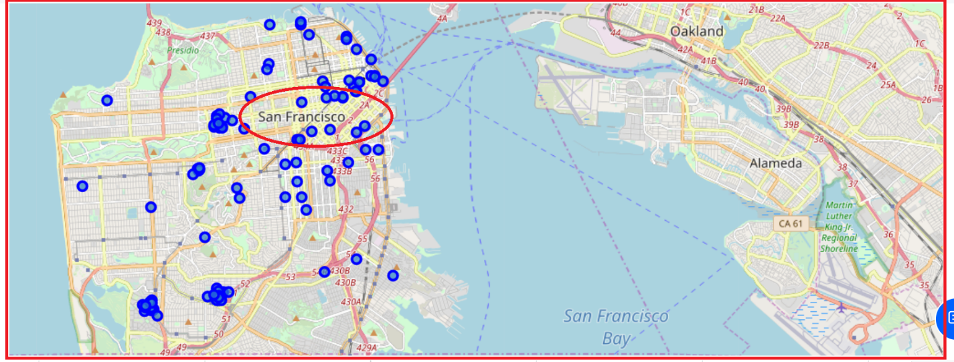

**Boston, MA**

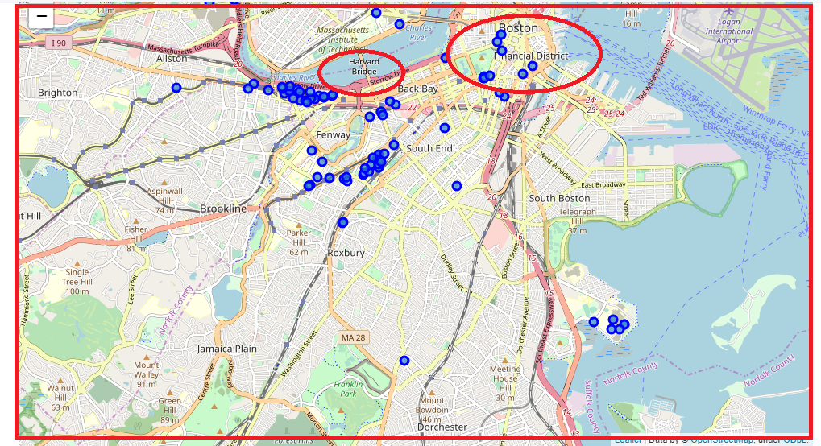

**Jersey City, NJ**

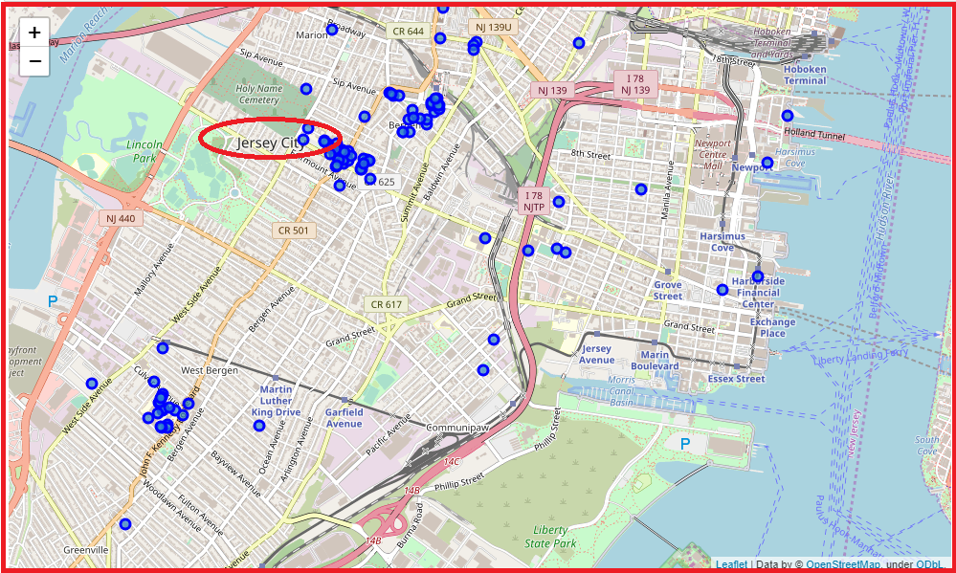

Therefore, our results are:

1. New York (244)
2. Boston, MA (244)
3. San Francisco (225)
4. Chicago (240)
5. Jersey City (132)

## **Discussion:**

**Observation 1: -** Based on the above research for XYZ company. I conclude that company should target first New York and Boston have more universities and colleges than other cities. In such city’s student life would be easier in terms of commute/transport. That is good idea to construct dorms and off campus in such locations. and We get more clarity using Data Visualization.

**Observation 2: -** I noticed in the figure is that there is a really far away universities in San Francisco that is probably giving it a higher Mean. So, I checked what if I removed it, it would not harm anyone. The new MDMC was: 0.0519953, putting it one place up on the list replacing Chicago, IL. One consideration to do further work on is to move the location of the Foursquare API query until we get all the universities places in each city and do the calculations again.

## **Conclusion:**

Based on the analysis i conclude that company should target first New York and Boston because of more universities and colleges than other cities. In such city’s student life would be easier in terms of commute/transport. That is good idea to construct dorms and off campus. Student prefer off campus and housing which are closer to collages and other facilities this decision is profitable to company because more student.

I have learned lot of techniques and modeling in this full course. This is great level of learning and lot of hands on labs will helpful to build tiny concepts from scratch (ML models recommender system, Python, IBM Watson, IBM SkillNet, folium). With this course we got better understanding of neighborhood with respect to most common venues using Foursquare API.

In future we can explore more analysis with respect to cost and other factors to run and start any business using ML techniques.